Contents
Topics to learn 4
1. Gradle project structure 4
2. Plain Java → Spring → Spring Boot 4
3. Spring Environment 4
4. Spring Bean Lifecycle (VERY IMPORTANT) 4
5. Configuration styles (CORE SKILL) 5
6. Dependency Injection patterns (DESIGN LEVEL) 5
7. Spring Boot auto-configuration (THE MAGIC) 5
8. Profiles + ConfigurationProperties (REAL WORLD) 6
9. Logging & Observability (ESSENTIAL) 6
10. Exception handling & Validation 6
11. Web layer (after foundations) 7
12. Data access (JPA/JDBC) 7
13. Testing (VERY IMPORTANT) 7
Plain Java 8
College class (simple POJO) 8
Main class (YOU manage everything) 8
No Spring means: 9
Coupling 9
Factory-style Java 10
Why plain Java does NOT scale well 10
Interview 10
Spring framework 11
Example 11
package 11
Import Statements 11
Class declaration 12
main method 12
Creating Spring Container 12
Getting a bean from Spring 13
Calling business logic 13
Execution flow 13
Spring Boot 14
Your CURRENT code (Plain Spring) 14
Above application using Spring Boot 14
Main Class 14
College class (almost same) 15
What changed? 15
What @SpringBootApplication really doing? 15
BENEFITS of Spring Boot 16
How to EXECUTE Spring Boot app 17
Project structure (Spring Boot way) 17
Interview 17
When should YOU use Spring Boot? 17
Environment in Spring 18
What Environment actually is? 18
Why Spring needs Environment 18
What can you do with Environment? 19
1. Read configuration properties 19
2. Check which profile is active 19
3. Provide default values safely 19
Why not just use @Value? 20
✅ Database switching 20
✅ Feature flags 20
✅ Logging config 20
How Spring populates Environment 21
Spring Boot vs Spring Framework 21
When SHOULD you use Environment? 21
When you should NOT 21
High level comparision 22
Hand on – Exercise to do 23
Gradle build file 23
application.properties (BASE configuration) 24
application-dev.yml (DEV profile) 24
application-prod.yml (PROD profile) 24
Main application class 24
Environment reader bean (MOST IMPORTANT PART) 25
Run scenarios (THIS IS WHERE YOU LEARN) 25
Property resolution order (MEMORIZE THIS) 27
REST API - Application 28
Create a Spring Boot project 28
Required dependency 28
Project structure (IMPORTANT) 28
Main Application class 29
Business logic (same as before) 29
REST Controller (NEW) 30
What annotations mean (VERY IMPORTANT) 30
How execution works (FLOW) 30
How to RUN the application 31
How to TEST the REST API 31
Why REST API is better than main() call 31
Interview one-liner 31
What next 32

Topics to learn

1. Gradle project structure
✔ src/main/java, resources, build.gradle
✔ Tasks, dependencies, lifecycle
This is build-time understanding

2. Plain Java → Spring → Spring Boot
✔ Object creation (new)
✔ IoC / DI
✔ @Component, @Configuration
✔ Auto-configuration
This is runtime architecture understanding

3. Spring Environment
✔ application.properties / yml
✔ Profiles
✔ Property resolution order

This is externalized configuration understanding

4. Spring Bean Lifecycle (VERY IMPORTANT)
When exactly is my object created, initialized, destroyed?
As part of this, you will learn
- Bean creation phases
- @PostConstruct
- @PreDestroy
- InitializingBean
- BeanPostProcessor
- Lazy vs eager beans
Because:
- Environment is read before beans
- Auto-configuration depends on lifecycle

5. Configuration styles (CORE SKILL)
Understand 3 ways of configuring Spring:
- Java Config (@Configuration)
- Component scanning
- Auto-configuration (Boot magic)
Focus on:
@ConditionalOnProperty
@ConditionalOnClass
@Profile
This connects Environment → Bean creation

6. Dependency Injection patterns (DESIGN LEVEL)
Learn how beans should depend on each other:
✔ Constructor injection (best practice)
❌ Field injection (why it’s bad)
✔ Qualifiers
✔ Primary beans
This is where clean architecture starts.

7. Spring Boot auto-configuration (THE MAGIC)
This is the most misunderstood topic.
Learn:
- spring.factories
- AutoConfiguration.imports
- How Boot decides what to create
- Why adding a dependency changes behavior
This explains why adding spring-boot-starter-data-jpa suddenly creates a DataSource

8. Profiles + ConfigurationProperties (REAL WORLD)
You already touched Environment, now master:
- @ConfigurationProperties
- @Validated
- Profile-specific configs:
- application-dev.yml
- application-prod.yml

This is enterprise-grade configuration.

9. Logging & Observability (ESSENTIAL)
Learn:
- SLF4J
- Logback
- Log levels per profile
- MDC
- Structured logging
Why?
Logs are your first debugger in production

10. Exception handling & Validation
Learn:
- @ControllerAdvice
- Global exception handling
- Bean validation (@NotNull, @Size)
- Custom exceptions
This separates toy apps from production apps.

11. Web layer (after foundations)
Only now move to:
- Spring MVC
- REST controllers
- Filters vs Interceptors
- Request lifecycle
Why later?
Web is just one entry point to Spring.

12. Data access (JPA/JDBC)
Learn:
- Transaction boundaries
- @Transactional
- Entity lifecycle
- Lazy vs eager fetching

13. Testing (VERY IMPORTANT)
Learn:
- Unit vs integration tests
- @SpringBootTest
- Slice tests
- Mocking beans

Plain Java

College class (simple POJO)
package com.testing.qe;

public class College {

public void principalName() {
System.out.println("Principal is Dr. Sharma");
}
}

If you look at above Java code
- No annotations
- No framework
- Just a normal Java class

Main class (YOU manage everything)
package com.testing.qe;

public class TestApplication {

public static void main(String[] args) {

// YOU create the object
College college = new College();

// YOU call the method
college.principalName();
}
}

No Spring means:
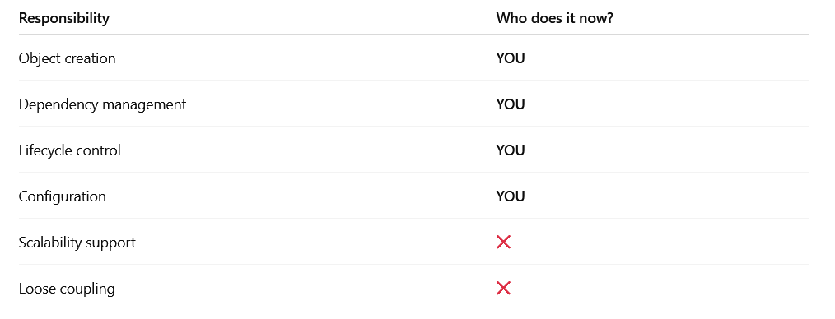

Coupling
With out Spring : Tight coupling
public class College {
private Principal principal = new Principal(); // hard-coded
public void showPrincipal() {
principal.name();
}
}
Problems:
- Cannot replace Principal
- Hard to test
- Code changes needed everywhere

With Spring : Loose coupling
@Component
public class College {
@Autowired
private Principal principal;
}

Spring:
- Creates Principal
- Injects it
- Allows easy replacement

Factory-style Java
Before Spring existed, people did this
public class ObjectFactory {

public static College getCollege() {
return new College();
}
}

Usage:
College college = ObjectFactory.getCollege();
Spring is basically a VERY powerful, configurable factory

Why plain Java does NOT scale well
Imagine:
- 50 classes
- Each depends on 5 others
Without Spring:
- 250+ new statements
- Tight coupling
- Nightmare to maintain
With Spring:
- Zero new
- Configuration-based wiring

Interview
✅ Small utility programs
✅ Simple learning demos
✅ One-class applications
❌ Enterprise apps
❌ REST APIs
❌ Database-heavy systems

Spring framework

Example
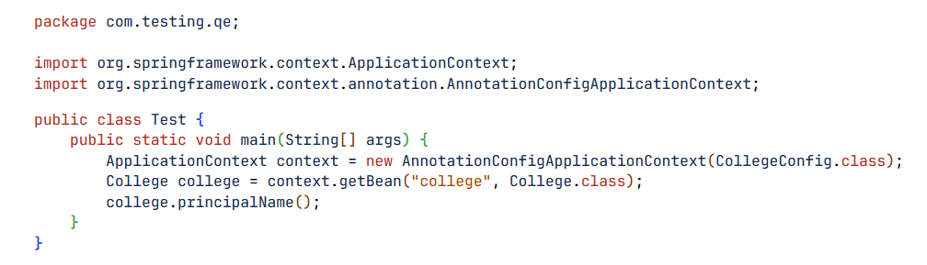

package
package com.testing.qe;
• This defines the package (namespace) of the class.
• It helps:
- Organize code
- Avoid class name conflicts
- Enable component scanning in Spring

Import Statements
import org.springframework.context.ApplicationContext;
import org.springframework.context.annotation.AnnotationConfigApplicationContext;
ApplicationContext  - Central Spring IoC container  - Responsible for:  - Creating objects (beans)  - Managing their lifecycle  - Injecting dependencies  Think of it as Spring’s factory + manager. | AnnotationConfigApplicationContext  - A concrete implementation of ApplicationContext  - Used when:  - Configuration is done using annotations  - No applicationContext.xml is used  This class:  - Reads @Configuration  - Scans @Component  - Handles @Bean, @Autowired, etc.

Class declaration
public class Test {
This is a plain Java class, not managed by Spring.
⚠️ Important:
- Test itself is not a Spring bean
- It just boots the Spring container

main method

public static void main(String[] args) {
• Java application entry point
• Starts Spring manually (not Spring Boot)

Creating Spring Container
ApplicationContext context = new AnnotationConfigApplicationContext(CollegeConfig.class);

What happens here step-by-step:
- Spring container is created
- CollegeConfig.class is loaded
@Configuration
@ComponentScan("com.testing.qe")
public class CollegeConfig {
}
- Spring:
- Reads @Configuration
- Scans packages for:
  - @Component
  - @Service
  - @Repository
  - @Controller
- Creates beans
At this moment, all beans are created and stored in the container.

Getting a bean from Spring
College college = context.getBean("college", College.class);
What this means:
- "college" → bean ID
- College.class → expected type
Spring:
- Looks for a bean named college
- Confirms it is of type College
- Returns the object
Usually defined as:
@Component
public class College {
public void principalName() {
System.out.println("Principal is Dr. Sharma");
}
}
Bean name defaults to class name with first letter lowercase.

Calling business logic
college.principalName();
• Calls method on Spring-managed object
• Any dependencies inside College are:
- Already injected
- Already initialized

Execution flow
JVM starts
↓
main() method executes
↓
Spring container starts
↓
Configuration class loaded
↓
Beans created & wired
↓
getBean() fetches object
↓
Method executed

Spring Boot
Compare your above Spring code with Spring Boot, then we will cover benefits and how to execute.

Your CURRENT code (Plain Spring)
ApplicationContext context = new AnnotationConfigApplicationContext(CollegeConfig.class);
College college = context.getBean("college", College.class);
college.principalName();
What YOU do manually
- Create ApplicationContext
- Create @Configuration class
- Add @ComponentScan
- Manage dependencies
- Decide how the app starts
This is pure Spring Framework.

Above application using Spring Boot

Main Class
package com.testing.qe;

import org.springframework.boot.SpringApplication;
import org.springframework.boot.autoconfigure.SpringBootApplication;
import org.springframework.context.ApplicationContext;

@SpringBootApplication
public class TestApplication {

public static void main(String[] args) {
ApplicationContext context = SpringApplication.run(TestApplication.class, args);
College college = context.getBean(College.class);
college.principalName();
}
}

No AnnotationConfigApplicationContext
No CollegeConfig needed

College class (almost same)

package com.testing.qe;

import org.springframework.stereotype.Component;

@Component
public class College {
public void principalName() {
System.out.println("Principal is Dr. Sharma");
}
}

What changed?
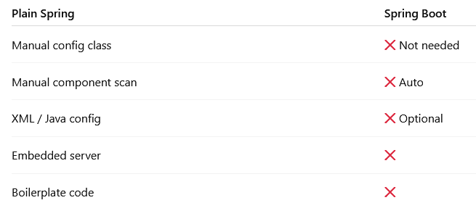

What @SpringBootApplication really doing?
@SpringBootApplication
This is 3 annotations combined
@Configuration
@EnableAutoConfiguration
@ComponentScan
Meaning:
- @Configuration → Java config
- @ComponentScan → scans current package & subpackages
- @EnableAutoConfiguration → magic ✨ (auto setup)

BENEFITS of Spring Boot

✅ 1. No configuration headache
- No XML
- No manual bean wiring
- No server setup

✅ 2. Auto-configuration (HUGE)
Example:
- Add spring-boot-starter-web
- BOOM 💥
  - Tomcat configured
  - DispatcherServlet created
  - JSON mapper ready
You didn’t write anything.

✅ 3. Embedded server
No need to install:
- Tomcat
- JBoss
- WebLogic
Spring Boot ships with embedded Tomcat.

✅ 4. Production-ready
Spring Boot gives:
- Health checks
- Metrics
- Logging
- Externalized config

How to EXECUTE Spring Boot app
Option 1: From IDE (IntelliJ / Eclipse)
- Right-click on TestApplication
- Click Run
✔ Most common
Option 2: Maven command
mvn spring-boot:run

Option 3: Run JAR (production way)
mvn clean package java -jar target/test-0.0.1-SNAPSHOT.jar

Project structure (Spring Boot way)
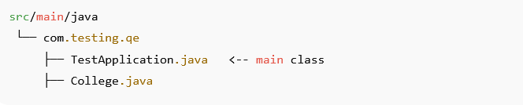
Main class must be at top package level
(or component scanning will fail)

Interview
Spring Boot = Spring + Auto Configuration + Embedded Server + Zero Boilerplate

When should YOU use Spring Boot?
✅ REST APIs
✅ Microservices
✅ Real-world projects
✅ Faster development

Environment in Spring

org.springframework.core.env.Environment is one of the most important abstractions in Spring, but it’s often used without really understanding why.

What Environment actually is?
In Spring Framework, Environment is an interface that represents:
The current runtime environment of your application
It gives you read-only access to:
- Configuration properties
- Active profiles
- Default profiles

Why Spring needs Environment
Modern applications don’t hardcode values like:
- Database URL
- Username/password
- Port numbers
- Feature flags
Instead, these values change by environment:
- dev
- test
- qa
- prod
Environment lets Spring centralize and resolve all of this configuration.

What can you do with Environment?

1. Read configuration properties
@Autowired
private Environment environment;

String url = environment.getProperty("spring.datasource.url");
This value could come from:
- application.properties
- application.yml
- OS environment variables
- JVM system properties
- Command-line arguments
You don’t care where it came from — Spring resolves it.

2. Check which profile is active
if (environment.acceptsProfiles("prod")) {
// production-only logic
}
Or:
String[] profiles = environment.getActiveProfiles();
This is extremely useful for:
- Logging
- Conditional behavior
- Feature toggles

3. Provide default values safely
String timeout =
environment.getProperty("app.timeout", "30");
If app.timeout is missing → "30" is used.
No NullPointerException.

Why not just use @Value?

You can do this:
@Value("${server.port}")
private int port;
But Environment is better when:
Use case | Why Environment is better
Dynamic access | Can read properties anytime
Conditional logic | Profiles + properties together
Optional properties | Built-in defaults
Libraries/frameworks | Cannot rely on @Value

Typical real-world use cases

✅ Database switching
if (environment.acceptsProfiles("dev")) { // H2 database } else { // Oracle / MySQL }

✅ Feature flags
if (environment.getProperty("feature.newUI", Boolean.class, false)) { enableNewUI(); }

✅ Logging config
log.info("Active profile: {}", Arrays.toString(environment.getActiveProfiles()));

How Spring populates Environment
Spring collects properties from PropertySources, in this order:
- Command-line args
- JVM system properties
- OS environment variables
- application.properties / yml
- @PropertySource
You can inspect them:
ConfigurableEnvironment env = (ConfigurableEnvironment) environment; env.getPropertySources().forEach(ps -> System.out.println(ps.getName()));

Spring Boot vs Spring Framework
In Spring Boot:
- Environment is auto-configured
- application.properties is loaded automatically
- Profiles are first-class citizens
In plain Spring:
- You must define property sources manually
But the Environment API is identical.

When SHOULD you use Environment?
✔ Framework / infrastructure code
✔ Conditional configuration
✔ Reading optional properties
✔ Profile-based behaviour

When you should NOT
❌ Simple POJOs
❌ Business logic classes
❌ Where @ConfigurationProperties fits better

High level comparision
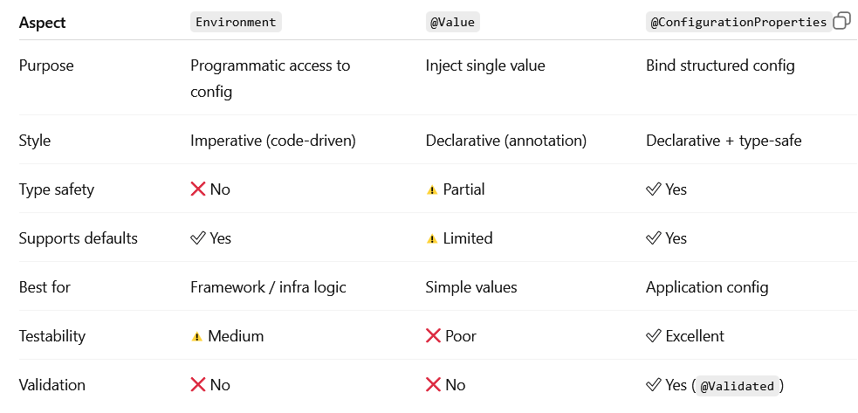

Hand on – Exercise to do
Create Project structure
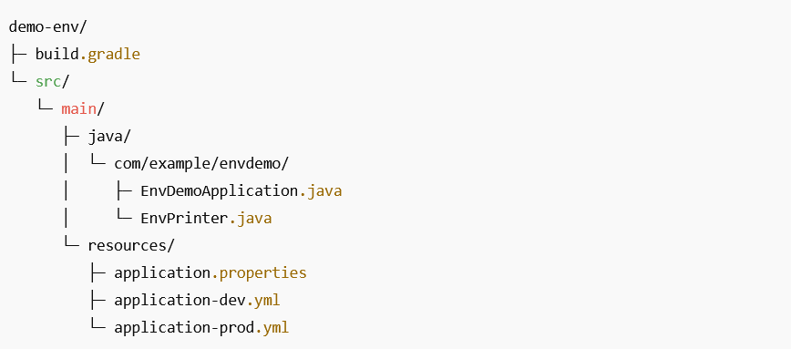

Gradle build file
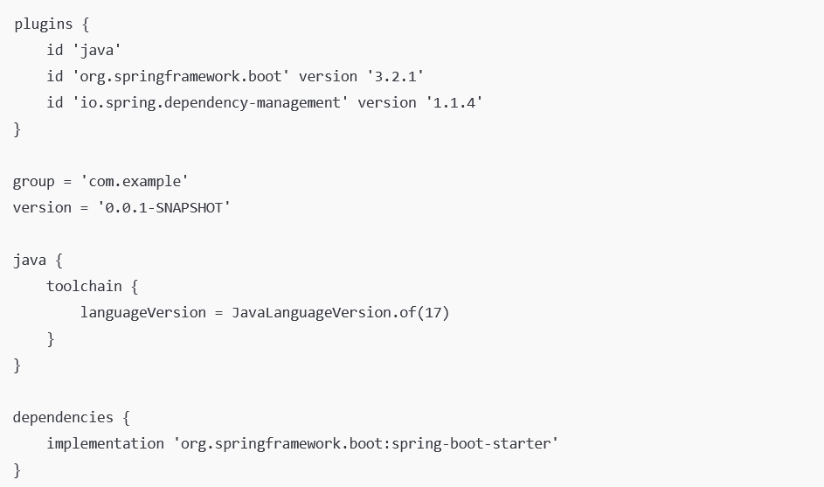
Note: This uses Spring Boot, which auto-wires the Environment

application.properties (BASE configuration)
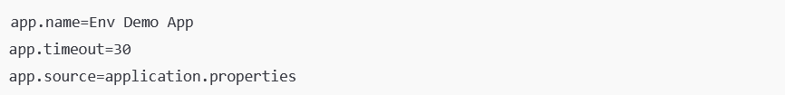

application-dev.yml (DEV profile)
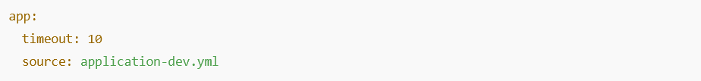
Note: Overrides only when dev profile is active.

application-prod.yml (PROD profile)
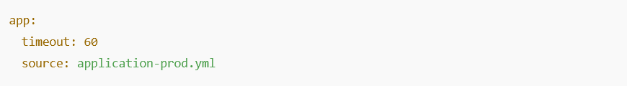
Note: Overrides only when prod profile is active.

Main application class
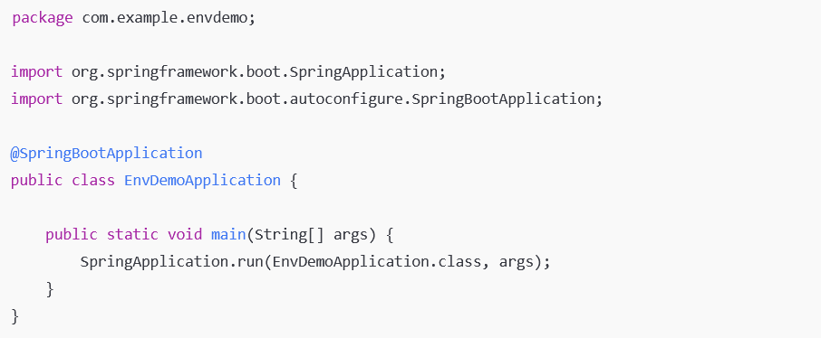

Environment reader bean (MOST IMPORTANT PART)
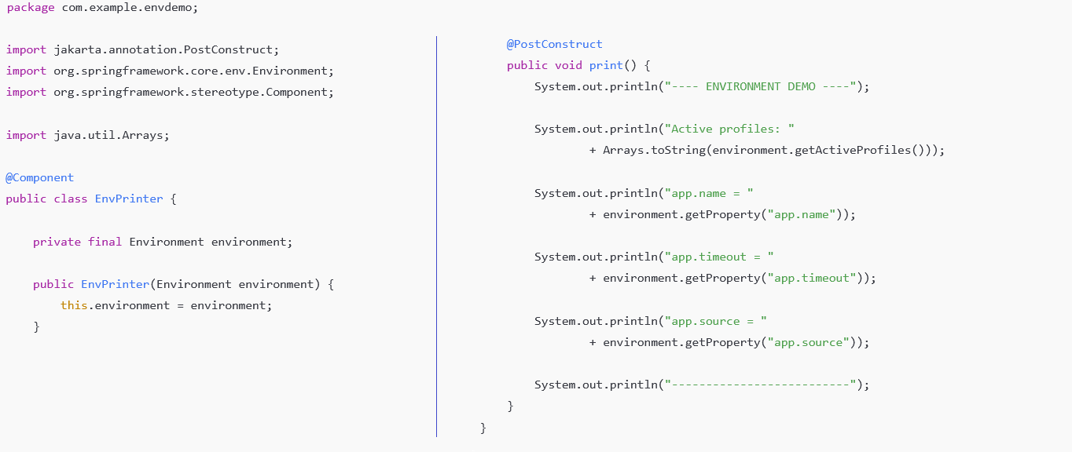
Note: This bean runs after the Environment is prepared, but before the app is fully ready.

Run scenarios (THIS IS WHERE YOU LEARN)

Case 1: No profile (default)
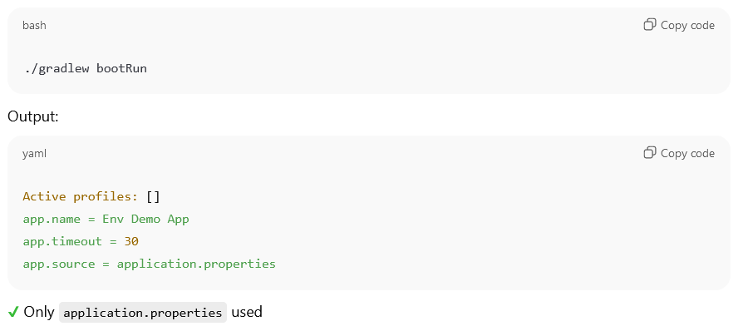

Case 2: DEV profile
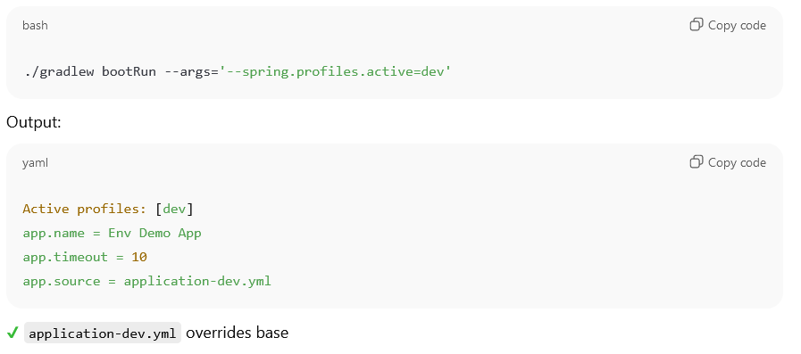
Case 3: PROD profile
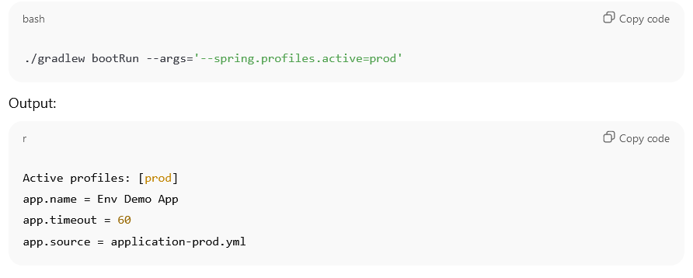
Case 4: Command-line override (HIGHEST PRIORITY)
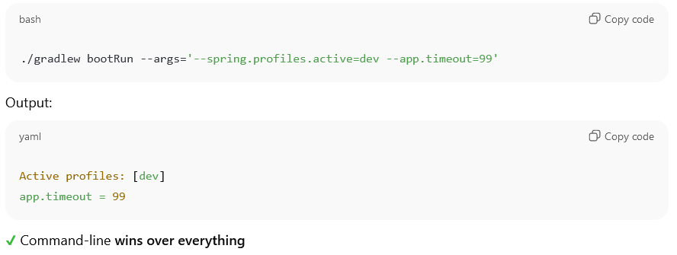

Property resolution order (MEMORIZE THIS)
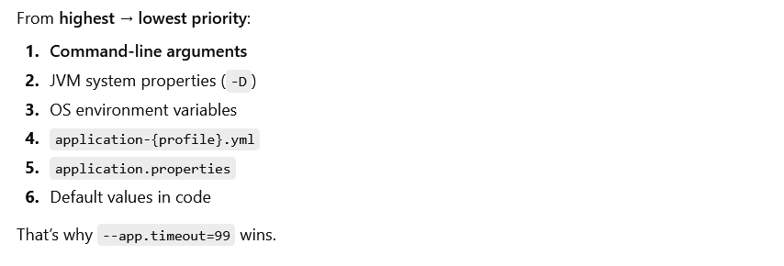

REST API - Application
Instead of calling:
college.principalName();
We will expose it as a REST endpoint:
GET http://localhost:8080/college/principal
and get a response like:
Principal is Dr. Sharma

Create a Spring Boot project
Use: IntelliJ / Eclipse OR

Required dependency
Add only Spring Web
(Maven dependency)
<dependency>
<groupId>org.springframework.boot</groupId>
<artifactId>spring-boot-starter-web</artifactId>
</dependency>
This is powered by Spring Boot, built on Spring Framework.

Project structure (IMPORTANT)
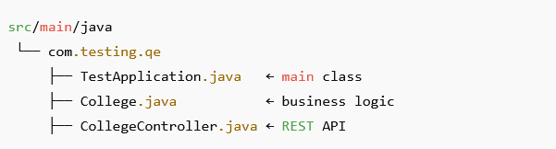
Main class must be at top package level.

Main Application class
package com.testing.qe;

import org.springframework.boot.SpringApplication;
import org.springframework.boot.autoconfigure.SpringBootApplication;

@SpringBootApplication
public class TestApplication {

public static void main(String[] args) {
SpringApplication.run(TestApplication.class, args);
}
}
✅ No ApplicationContext
✅ No config class
✅ No manual wiring

Business logic (same as before)
College.java
package com.testing.qe;

import org.springframework.stereotype.Component;

@Component
public class College {

public String principalName() {
return "Principal is Dr. Sharma";
}
}

✔ Spring manages this bean
✔ No new College() anywhere

REST Controller (NEW)
CollegeController.java
package com.testing.qe;

import org.springframework.beans.factory.annotation.Autowired;
import org.springframework.web.bind.annotation.GetMapping;
import org.springframework.web.bind.annotation.RestController;

@RestController
public class CollegeController {

@Autowired
private College college;

@GetMapping("/college/principal")
public String getPrincipalName() {
return college.principalName();
}
}

What annotations mean (VERY IMPORTANT)
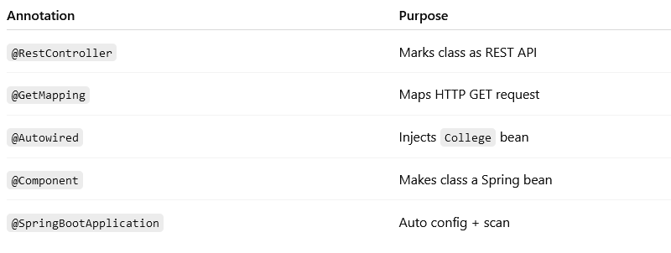

How execution works (FLOW)
Browser / Postman
|
| GET /college/principal
v
CollegeController
|
v
College (business logic)
|
v
Response returned

How to RUN the application
✅ Option 1: From IDE
- Right-click TestApplication
- Click Run
✅ Option 2: Maven
mvn spring-boot:run

✅ Option 3: JAR (production style)
mvn clean package java -jar target/*.jar

How to TEST the REST API
In browser
http://localhost:8080/college/principal

In curl
curl http://localhost:8080/college/principal

Why REST API is better than main() call
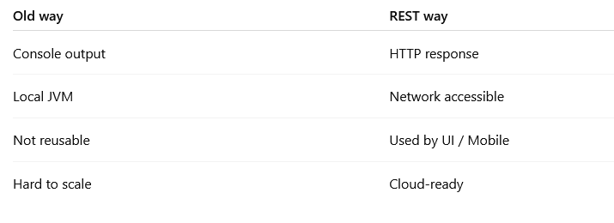

Interview one-liner
Spring Boot REST API exposes business logic using HTTP endpoints, making applications scalable, reusable, and platform-independent.

What next
• Convert response to JSON
• Add POST API
• Add DTO
• Connect to Oracle DB
• Explain @RestController vs @Controller

